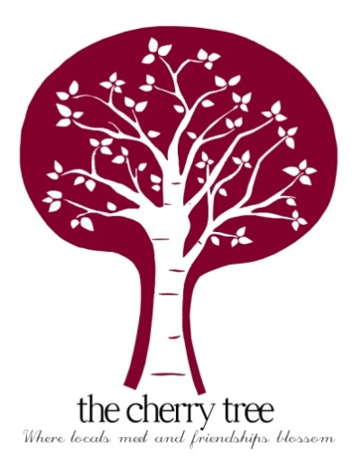
Christmas Menu

STARTERS

Curried parsnip soup, parsnip crisps, flatbread
-
Ham hock & herb terrine, spiced pineapple chutney, toast
-
Black treacle glazed smoked salmon, taramosalata, pickled kholrabi
-
Olive, sunblushed tomato & roasted pepper salad, hummus, pitta, halloumi

MAIN COURSE

Local roast turkey crown, pigs in blankets, stuffing, roast potatoes, sprouts, glazed carrots, mustard roasted parsnips
-
Tofu or pork belly Thai green curry, aromatic rice, spring onions, coriander
-
Smoked fish pie, gruyere mash, buttered leeks & cabbage
-
Slow braised beef shin and Blackshore stout stew, horseradish mash, roasted root vegetables

DESSERTS

Christmas pudding, whipped brandy Greek yoghurt
-
Mint choc chip cheesecake, chocolate ice cream
-
White wine poached pear, olive oil crumble, pear sorbet, chocolate sauce
-
Cheese & biscuits, fig chutney, grapes

3 courses - £ 27.00 per person
2 courses - £ 21.50 per person
01394 384627
Due to Government guidelines we cannot accommodate groups larger than 6 people

In an effort to reduce waste and single use plastic we are not providing Christmas crackers this year

