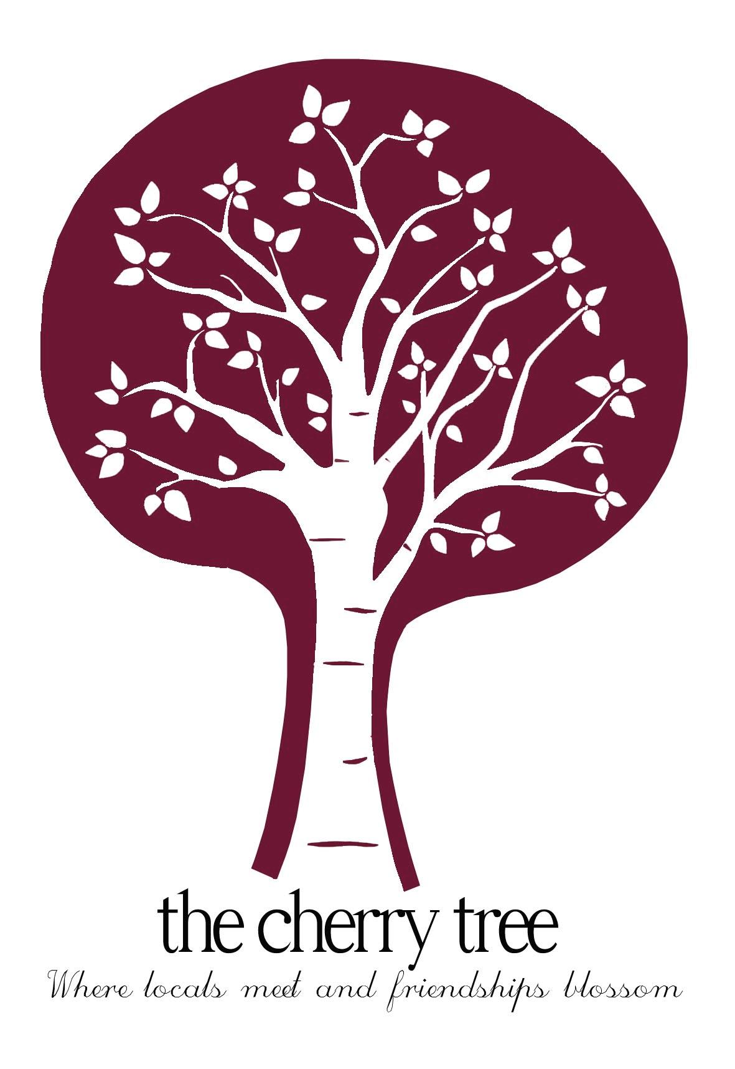 The Cherry Tree

£8.50 each
Satay Sweet Potato & butternut squash Curry coriander basmati rice, topped with chilli cashews and peanuts (vegan)

Beef and Ale Stew Roasted root vegetables, new potatoes, thyme dumplings

Falafel Burger pitta bread bun, gem lettuce salad, sweet potato fries (vegan)

Homemade Chargrilled 7oz Steak Burger griddled bacon, sliced monterey jack cheese, handcut chips
Beer Battered Fish handcut chips, mushy peas
Banger & Mash Procters’ Old English sausages, creamy mash, garden peas

01394 384627
Free delivery within 5 miles of the pub

