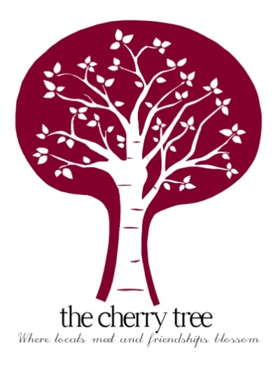
Christmas Menu
STARTERS

Roasted Red Pepper and Sweet Potato Soup, Herb Croutons
-
Skewered King Prawns in a Smoked Paprika and Herb Butter, Sun Blushed Tomato and Rocket Salad, Chargrilled Ciabatta
-
Terrine of Duck with Juniper and Pistachio Nuts, Cranberry and Orange Compote
-
Deep Fried Breaded Brie Bites, Watercress Salad, Balsamic Glaze

MAIN COURSE

Local Roast Turkey Breast, Pigs in Blankets, Cranberry and Sage Pork Stuffing, Roast Potatoes, Red Wine Gravy Roasted Root Vegetables, Cranberry Sauce
-
Oven Baked Cod Loin, Parmentier Potatoes, Chorizo and Wilted Spinach
-
Slow braised rolled Belly of Pork, Roasted Celeriac, Parsnip Puree, Adnams Wild Wave Cider Gravy
-
Proctors Venison and Forest Fruits Sausages, Creamy Mashed Potato, Mulled Wine Braised Red Cabbage, Caramelised Onion Gravy

Vegan Chestnut Mushroom Wellington, Garlic and Thyme Roasted New Potatoes, Roasted Root Vegetables, Vegan Gravy (V)(Ve)

DESSERTS

Dark Chocolate and Orange Brioche Bread and Butter Pudding, Creamy Custard
-
Chocolate Fudge Brownie, Vanilla Ice Cream, Raspberry Coulis
-
Traditional Christmas Pudding, Brandy Custard
(Vegan Optional)
-
Pomegranate Cheesecake, Passion Fruit Coulis

3 courses - £26 per person
2 courses - £20 per person
01394 384627

In an effort to reduce waste and single use plastic we are not providing Christmas crackers this year

